Project Planning Phase
Project Planning Template — Product Backlog, Sprint Planning, Stories & Story Points
Date | Team ID | Project Name | Maximum Marks
1 October 2026 | SWTID-2026-3491 | Import Data using Transform Maps (Spreadsheet) | 5 Marks

Product Backlog, Sprint Schedule and Estimation
Sprint | Epic | Story No. | User Story / Task | Points | Priority | Team
Sprint 1 | Data Preparation | USN-1 | As an administrator, I can prepare an employee spreadsheet with Employee ID, Employee Name, Email, Department and Location. | 2 | High | Team
Sprint 1 | Target Table | USN-2 | As an administrator, I can create Employee Test (u_employee_test) with the required employee fields. | 3 | High | Team
Sprint 1 | Import Set | USN-3 | As an administrator, I can load the spreadsheet into Employee Import (u_employee_import) using Load Data. | 2 | High | Team
Sprint 1 | Transform Map | USN-4 | As an administrator, I can create Sample Spreadsheet Import from Employee Import to Employee Test. | 2 | High | Team
Sprint 1 | Field Mapping | USN-5 | As an administrator, I can verify source-to-target field mapping using Auto Map and Mapping Assist. | 2 | High | Team
Sprint 2 | Transform & Validation | USN-6 | As an administrator, I can run the transform and verify successful employee records in Employee Test. | 2 | High | Team
Sprint 2 | Duplicate Handling | USN-7 | As an administrator, I can enable Coalesce on Employee ID so matching records update instead of duplicating. | 3 | High | Team
Sprint 2 | Repeat Import | USN-8 | As an administrator, I can upload a follow-up spreadsheet and inspect inserted, updated and ignored outcomes in transform history. | 2 | High | Team
Sprint 2 | Reports | USN-9 | As a reviewer, I can create department pie/count, location bar/count and employee list reports. | 3 | Medium | Team
Sprint 2 | Dashboard | USN-10 | As a reviewer, I can add all three reports to Employee Analytics Dashboards. | 3 | Medium | Team

Project Tracker, Velocity & Burndown
Sprint | Total Points | Duration | Planned Start | Planned End | Completed Points | Actual Release
Sprint 1 | 11 | 5 working days | 5 Oct 2026 | 9 Oct 2026 | To be recorded | To be recorded
Sprint 2 | 13 | 5 working days | 12 Oct 2026 | 16 Oct 2026 | To be recorded | To be recorded
Planned average velocity = (11+13) / 2 = 12 story points per sprint. Actual velocity must use completed story points.
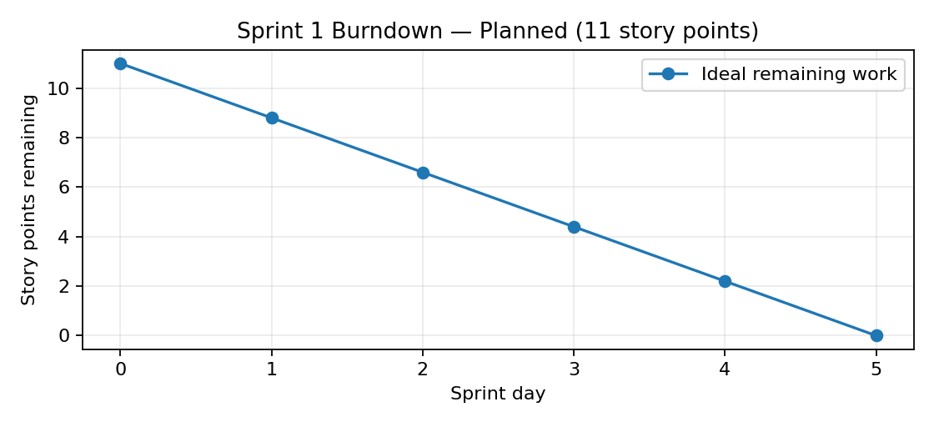
Burndown chart shown as an ideal planned line. Update remaining work each sprint day with actual progress.

